Corner Placement
The corners must first be placed into their correct position. Do not worry about their orientation yet; at this point you are only concerned with placement. Twist the bottom-layer so that the greatest number of cubes is in their correct position. If two or more cubes are opposing their correct corner, you will need to swap them. You may need to do this twice. Place the two corners that need to be swapped on the front-face and perform this combination:
Corner Swap
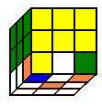 Yellow is the front-face 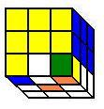Right view
Right ↓ Bottom ← Right ↑ Front →
Bottom → Front ← Right ↓ Bottom →
Right ↑ Bottom →→
Corner Orientation
Now that you have all of the bottom-corner cubes in their proper position, you can start working on their orientation. First, check to see if you have any cubes oriented correctly. Look at the bottom-face to determine your patterns. You want one, and only one, cube in the correct orientation. This is because the Three Corner Shuffle shuffles only three cubes while leaving one in place. Place the cube that is correctly oriented in the top-left corner while looking at the bottom-face. This combination will take the top-right color that is on the front-face and place it on the bottom-face:
Three Corner Shuffle
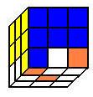Blue is the front-face 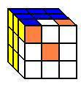Bottom view
Right ↓ Bottom ← Right ↑ Bottom ←
Right ↓ Bottom →→ Right ↑
Bottom →→
If the cube on the right is not the bottom-face color, then turn the whole cube so that the solved bottom-corner cube is on the right side of the front-face. If the left corner-cube is the bottom-face color, perform this combination:
Other Corner Orientation Patterns
If you do not have a corner that is correctly oriented, then look at the bottom-face for one of these patterns and perform the Three Corner Shuffle (Note: orange demonstrates the bottom-face. Yellow is used to demonstrate the front-face. The actual color of the front-face may vary.):
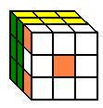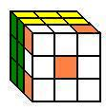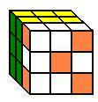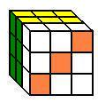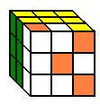
Perform the Three Corner Shuffle until you get one of the two desired patterns in the section above.

Bottom Edges
Check the bottom-edges to see if any bottom-edge cubes are placed correctly. Next, look at the bottom-edge patterns to determine which combination you need to perform. If no cubes are correctly placed, choose a combination that will correctly place at least one bottom-edge cube to obtain a solved front-face. The bottom edge 1 and 2 combinations focus on the cube on the bottom left side. The mirrors focus on the cube on the bottom right side. This will help you in deciding which combination to use.
Bottom Edge 1
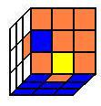 Bottom view (Blue represents the back-face)

Left ↑ Right ↑ Front ← Left ↓
Right ↓ Bottom →→ Left ↑ Right ↑
Front ← Left ↓ Right ↓
Bottom Edge 1 Mirror
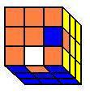Bottom view (Blue represents the back-face)
Left ↑ Right ↑ Front → Left ↓
Right ↓ Bottom →→ Left ↑ Right ↑
Front → Left ↓ Right ↓
Bottom Edge 2
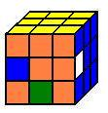Bottom view (Yellow represents the front-face)
Front → Left ↓ Back → Left ↑
Back ← Front ← Bottom → Back ←
Bottom ← Back →
Bottom Edge 2 Mirror
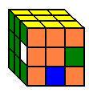 Bottom view (Yellow represents the front-face)
Front ← Right ↓ Back ← Right ↑
Back → Front → Bottom ← Back →
Bottom → Back ←
Other Bottom Edge Patterns
Here are the other common bottom-edge patterns that you will see. Select your pattern and perform the combinations listed. Keep the same front-face throughout the series of combinations. If you do not have one of these patterns, look at the bottom-cubes on the right and left sides to decide which cube to place. Choose a combination that will get you one of the common patterns.
Bottom Edge Pattern 1
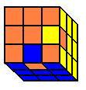 Bottom view (Blue represents the back-face.)
For this pattern, perform a Bottom Edge 1 followed by a Bottom Edge 2 combination. Be sure to keep the same front-face throughout the series of combinations.
Bottom Edge Pattern 2
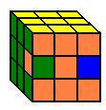 Bottom view, left side (Yellow represents the front-face)
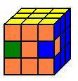Bottom view, right side (yellow represents the front-face)
For this pattern, perform a Bottom Edge 2 followed by a Bottom Edge 1 combination. Be sure to keep the same front-face throughout the series of combinations.
Conclusion
It will take some practice to learn all of the combinations and color patterns. Watch each combination closely as you learn them to see what effect they have in orienting the cubes. This will help you to understand what each combination does, which will help you to decide which combination to use. It is not possible to include every pattern, so learning what each combination is doing would be invaluable. Making quick decisions is important to building speed.
Once you have learned the combinations and patterns, Rubik’s Cube can consistently be solved in one minute or less. I average less than one minute with my fastest time being somewhere between 30 and 40 seconds (not counting the times I got lucky). Good luck. Once you have solved your cube and bragged to your friends, mix it up and do it again!

